IEEE NITK CHAPTER

PROJECT – CONNECT 4 WITH AI

|  |  |
| --- | --- |
|  | **ABSTRACT**  *The goal of this project is to recreate the popular game ‘Connect 4’. We intend to have both single and multiplayer modes with the single player mode played against an AI. The AI will be constructed using the minimax algorithm and optimized using alpha beta pruning and tabulation. Finally, we will add a graphic user interface.* |

# Section 1 – project overview

|  |  |
| --- | --- |
|  | *The proposal is divided into two sections namely – Project Overview and Literature Review. The first section will cover the motivation, objectives, methodology, timeline, budget and deliverables of the project. The second section contains the literature review regarding the different phases of the project.* |

## The Motivation

We chose this project because it is very interesting and gives us an opportunity to work with python and AI. It gives us an opportunity to build something worthwhile with our skills. Also, it isn’t very complex and therefore an excellent choice as a starter project for the juniors. Moreover connect 4 is a popular game and something we are quite familiar with so we hope to enjoy building this project and learn new things along the way.

## The Opportunity

This project gives an opportunity for the freshers to learn python and gain some hands-on experience in an emerging field. It would give them an opportunity to simultaneously delve into python and AI, which are two of the most demanded skills in Computer Science. They would also have a chance to learn Git and GitHub which are irreplaceable for management and integration of code during a project. After that, they will get to deploy their work as a web app. All of this would give them an invaluable insight into project workflow.

## The Objective

1) To learn Python and write modular and maintainable code.

2) Get familiar with Git version control and GitHub.

3) To implement a 2 player connect 4 game and then use AI to automate it.

## Project Approach

We intend to hold weekly meetings to distribute the workload and provide resources which are required for that particular week. We, as mentors would be always available to resolve doubts and guide the juniors on every step of this project. As the project progresses stagewise (as specified in the timeline below) we would work on meeting the milestones on time and ensure that we learn something new along the way and of course, have fun doing it.

## Project Deliverables

The following are the full list of deliverables which will be achieved through the entire project timeline:

|  |  |
| --- | --- |
| **Deliverable** | **Description** |
| Complete version of the game using CLI. | The version does incorporate AI but uses the CLI for user interaction. |
| Complete version of the game using GUI. | Using pygame we built a GUI |

The final version of the game includes (but is not limited to) the following features:

* Two player mode.
* Single player mode with adjustable difficulty levels – Easy, Medium and Hard.
* Game review – Once the game is over the player can look back at the sequence of moves made by them and what the AI calculated as the best move to compare the two.
* Customizable GUI – Allow the user to pick dark/light themes

If we manage to meet all the milestones and have time to spare, we would like to implement the following as well:

* Game statistics – stores number of games played, win percentage, longest winning streak etc.
* Store the game reviews for the last few games.
* A “Very Easy” difficulty level where the AI just makes randomized moves.

Here’s how we expect the game to look like once we’ve implemented it:

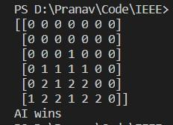 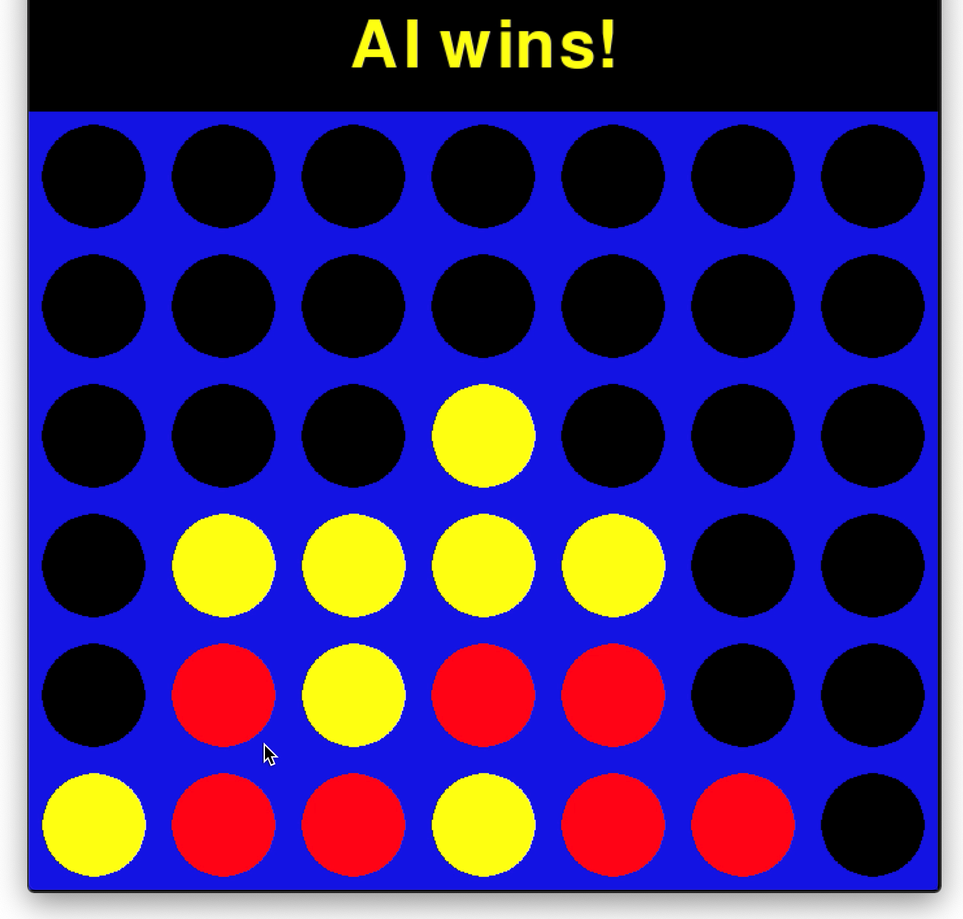

**CLI Version** **GUI Version**

## Timeline for Execution

Key project dates are outlined below. Dates are best-guess estimates and are subject to change until a contract is executed.

|  |  |
| --- | --- |
|  | *In the Table below, the dates and duration of the project are tentative and subjected to change as it depends on the availability of resources to accomplish some tasks.* |

|  |  |  |  |
| --- | --- | --- | --- |
| **Description** | **Start Date** | **End Date** | **Duration** |
| Project Phase 1 | | | |
| Milestone 1:  Description: To learn basics of Git, GitHub and project workflow. | Feb 8 | Feb 15 | One week |
| Milestone 2:  Description: To learn Python in order to write modular and maintainable code. | Feb 16 | March 1 | Two weeks |
| Project Phase 2 | | | |
| Milestone 3:  Description: To implement a simple 2 player version of the game. | March 2 | March 15 | Two weeks |
| Milestone 4:  Description: To implement the minimax algorithm for single player mode. | March 16 | March 31 | Two weeks |
| Project Phase 3 | | | |
| Milestone 5:  Description: To optimize the minimax algorithm using alpha beta pruning and tabulation. | April 9 | April 30 | Three weeks |
| Milestone 6:  Description: To work on additional features like game review and difficulty scaling. | May 1 | May 15 | Two weeks |
| Project Phase 4 | | | |
| Milestone 7:  Description: To implement a graphic user interface (the previous versions use a command line interface to play the game). | May 16 | June 8 | Three weeks |
| Project Phase 5 | | | |
| Milestone 8:  Description: (If time permits) To implement “game statistics”, store data from the past few games, or make a randomized AI |  |  |  |
| Project End | | | |

## Budget

|  |  |
| --- | --- |
|  | *Disclaimer: The prices listed in the preceding table are an estimate for the services discussed. This summary is not a warranty of final price. Estimates are subject to change if project specifications are changed or costs for outsourced services change before a contract is executed.* |

|  |  |
| --- | --- |
| **Name of Item** | **Estimated Price** |
| Division 1 | |
|  |  |
|  |  |
|  |  |
|  |  |
|  |  |
|  |  |
|  |  |
| **Total:** | 0 |
| Division 2 | |
|  |  |
|  |  |
| **Total:** | 0 |
| Other | |
|  | 0 |
| **Estimated Total** |  |

## References

* <https://connect4.gamesolver.org/en/>
* <https://www.youtube.com/watch?v=STjW3eH0Cik>
* <https://www.youtube.com/watch?v=XpYz-q1lxu8>
* <https://www.youtube.com/watch?v=8392NJjj8s0>
* <https://git-scm.com/book/en/v2>
* <https://roadtolarissa.com/connect-4-ai-how-it-works/#:~:text=The%20connect%204%20playing%20program,considered%20has%20actually%20taken%20place>.
* <https://www.python.org/>

# SECTION 2 – LITERATURE REVIEW

## About connect 4:

Connect Four is a two-player [connection](https://en.wikipedia.org/wiki/Connection_game) board game, in which the players choose a color and then take turns dropping colored discs into a seven-column, six-row vertically suspended grid. The pieces fall straight down, occupying the lowest available space within the column. The objective of the game is to be the first to form a horizontal, vertical, or diagonal line of four of one's own discs. Connect Four is a solved game. The first player can always win by playing the right moves.

<http://blog.gamesolver.org/>

<https://blogs.cornell.edu/info2040/2015/09/21/solving-connect-four-with-game-theory/>

## Minimax Algorithm and Alpha Beta Pruning:

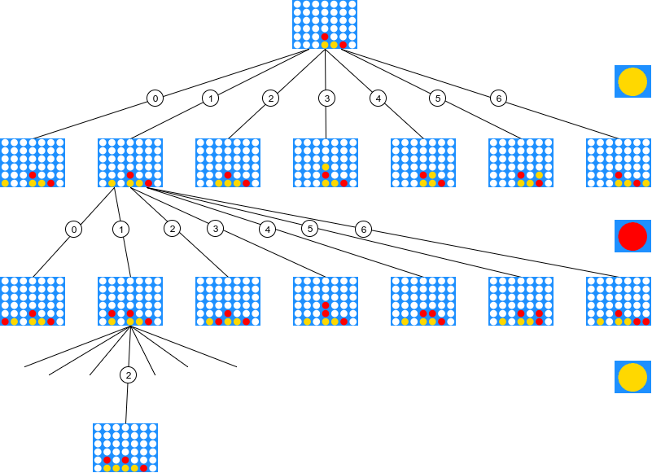

<https://www.javatpoint.com/mini-max-algorithm-in-ai>

<https://www.javatpoint.com/ai-alpha-beta-pruning>

<https://medium.com/analytics-vidhya/artificial-intelligence-at-play-connect-four-minimax-algorithm-explained-3b5fc32e4a4f>

## GUI using Pygame:

<http://programarcadegames.com/index.php?lang=en&chapter=introduction_to_graphics>

## Information on NumPy:

<https://numpy.org/>

## Mentors:

1. **Sanjkeet Jena (Email -** [**iamkeet.191cs246@nitk.edu.in**](mailto:iamkeet.191cs246@nitk.edu.in)**, Ph – 77357 78182)**
2. **Pranav DV (Email –** [**pranavdv.191cs234@nitk.edu.in**](mailto:pranavdv.191cs234@nitk.edu.in)**, Ph – 77607 85980)**